Hotel Istana Kuala Lumpur City Centre
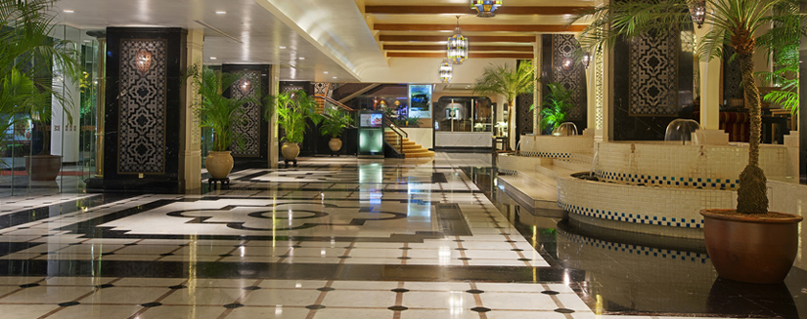
http://www.hotelistana.com.my/

73 Jalan Raja Chulan, 50200 Kuala Lumpur, Malaysia
Tel: +603 2141 9988 begin_of_the_skype_highlighting +603 2141 9988 免費 end_of_the_skype_highlighting Fax: +603 2144 0111

10-minute walk from Kuala Lumpur Convention Centre and famous Petronas Twin Towers

Hotel Istana Kuala Lumpur City Centre | 5 Star Hotel in Kuala Lumpur, Malaysia
Located in Kuala Lumpur City Centre (Google Map)
5 minutes walk to Bukit Bintang Shopping and Pavillion Kuala Lumpur
5 minutes walk to Changkat Bukit Bintang, the NEW hype in town!!
5 minutes walk to Kompleks Kraf Kuala Lumpur (Kuala Lumpur Craft Centre)
10 minutes walk to Kuala Lumpur Convention Centre (KLCC) via the new Skybridge

The 5 star business hotel features 505 well-appointed guestrooms and suites designed to suit every individual's personal and corporate needs.
- Complimentary broadband in all accommodation rooms running at 25Mbps.
- Complimentary wifi in restaurants and lounge.

For delightful dining in Kuala Lumpur, guests can savour the authentic tastes from our outstanding restaurants
For your ideal meetings in Kuala Lumpur, Hotel Istana Kuala Lumpur City Centre is your perfect choice
- Grand Mahkota Ballroom I, II, III catering up to 2000 guests.
- 14 versatile meeting rooms of variable sizes.
- Well-appointed business centre providing a comprehensive range of secretarial support services.

Leisure facilities include:
- Fully equipped Fitness Centre
- Swimming Pool
- Sauna
- Jacuzzi
- Spa and many others for your enjoyment.

五星級Hotel Istana酒店現代而優雅，俯瞰著吉隆坡市中心，距離Bukit Bintang購物區只有短短的5分鐘步行路程，提供免費停車場和一個室外游泳池。

Hotel Istana Kuala Lumpur酒店距離吉隆坡會議中心和雙峰塔(Petronas Twin Towers)有10分鐘步行路程。

Hotel Istana酒店的客房均配有空調和寬大的窗戶，俯瞰著吉隆坡的優美都市風光。每間客房均配備有線/衛星電視、沏茶/咖啡設施和免費有線網絡。

