Achieving Greatness Together |  |  | The mission of a Toastmasters club:  We provide a supportive and positive learning experience in which members are empowered to develop communication and leadership skills, resulting in greater self-confidence and personal growth.
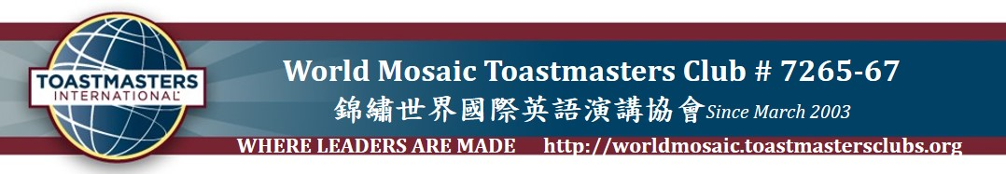
Frequency | 1st & 3rd Thursdays of every month  每月第一及第三個星期四 |  |  | Admission Fee |  | NT$100 for Guests and members  Free for Students
Venue | Fellow Guangxian Association Taipei:  (台北市廣西同鄉會):  7F, No. 35, Section 1, Zhōngxiào East Road, Jhongjheng District, TaipeiCity  (台北市忠孝東路一段35號7樓) |  |  | Public transportation  or Parking |  | MRT: Shan Dao Temple station Exit 6  (善導寺站6號出口，步行1分鐘)  Bus: 審計部站 (Ministry of Audit),  via 212, 202, 605, 232, 299, 257,  忠孝幹線 (Zhongxiao New Main Line)  Parking: Roadside Parking on Linsen South Road. or Shaoxing North Road  (林森南路或紹興北路路邊停車格)
Website  Facebook | http://worldmosaic.toastmastersclubs.org  World Mosaic Toastmasters Club |  |  | Time |  | Registration 18:30  Meeting 19:00 - 21:00
 | World Mosaic Meeting No. |  |  | 272 Thursday, September 04, 2014
 | Annual Event: |  |  | Evaluation Night
Duration Time  (min) | Start Time  (PM) | Program |  |  | Participant / Host
30 | 6:30 | Registration
3-5 | 7:00 | Welcome |  |  | Jane Tseng, VPM, IPP
4-6 | 7:06 | Toastmaster of the Evening (TME) |  |  | Jane Tseng, VPM, IPP
3 | 7:13 | Timer  Ah Counter
Total 25 | 7:17 | *** REMINDER: COMMUNICATION & LEADERSHIP MANUALS EXCHANGE ***
 |  | Prepared Speech Session |  |  | Speaker |  | Evaluator
5-7 | 7:17 | Title: I Come From Tainan  Project 3: Get To The Point  Manual: Competent Communication |  |  | Sweater Shih, CC, Secretary |  | Richard Lo, TME
5-7 | 7:25 | Title: Sleeping  Project 7: Research Your Topic  Manual: Competent Communication |  |  | Roy Hung, SAA |  | Eddie Chen, President
5-7 | 7:33 | Title:  Project 8: Get Comfortable With Visual Aids  Manual: Competent Communication |  |  | Dennis Lan, VPPR |  | Quentin Lee, CC, Treasure
5 | 7:41 | Guests Introduction  (30 sec – 1 min Self-Introduction) |  |  | Beck Chen, CC, President
10 | 7:47 | *** INTERMISSION ***
 |  | Evaluation Session |  |  | Evaluator |  |  | Senior Evaluator
2 | 7:47 | 1st Timer & Ah Counter Reports
2-3 | 7:50 | Individual Evaluator # 1 for Sweater |  |  | Taipei Phoenix-Richard Lo |  |  | Helen Chen
2-3 | 7:54 | Individual Evaluator # 2 for Roy |  |  | Premium-Eddie Chen |  |  | L.J. Lamb
2-3 | 7:58 | Individual Evaluator # 3 for Dennis |  |  | World Mosaic-Quentin Lee |  |  | Tim Huang
2-3 | 8:05 | Senior Individual Evaluator # 1 for Richard |  |  | Tim Huang, CC, ALB, G1 Governor
2-3 | 8:09 | Senior Individual Evaluator # 2 for Eddie |  |  | L.J. Lamb, DTM4
2-3 | 8:13 | Senior Individual Evaluator # 3 for Quentin |  |  | Helen Chen, DTM, Division G Governor
2 | 8:02 | 2nd Timer & Ah Counter Reports
5-7 | 8:17 | General Evaluator |  |  | George Yen, Charter President
5 | 8:25 | Awards, Announcement, Guests Comments |  |  | Jane Tseng, VPM, IPP
 | 8:31 | Meeting Adjourned & Take Group Pictures |  |  | Jane Tseng, VPM, IPP

Officer Team 2014-2015
President | Beck Chen | 0952-538-863 | chenbeck@gmail.com
VP Education | Ann Wei | 0988-497-927 | a1b2c3d4e540@yahoo.com.tw
VP Membership, IPP | Jane Tseng | 0921-629-126 | ricky802@ms37.hinet.net
VP Public Relations | Dennis Lan | 0988-250-945 | kyocartoon@gmail.com
Secretary | Sweater Shih | 0910-787-323 | weges@hotmail.com
Treasurer | Quentin Lee | 0988-025-315 | lee.rhapsody@gmail.com
Sergeant at Arms | Roy Hung | 0953-943-686 | roy0956307664@gmail.com
Charter President 2003 | Helen Chen, DTM | 0937-099-317 | Helen_hc1@yahoo.com

Minutes Taker on August 21, 2014 Meeting |  |  | Awards | Best Prepared Speaker | Anna Kao
Attendants | Members | 11 / 22 |  | Best Table Topics Speaker | Leo
 | Guest | 7 |  | Best Evaluator | Roy Hung
 | Total | 18 |  | Best Session Master | Mike Lee
Time Control | Start | 07:04 |  | Most Improved Speaker | Dennis Lan
 | Adjourned | 09:16 |  | Best Humor | Heather Tsai

General Evaluation summary on August 21, 2014
- The meeting starts on time.
- Someone cannot attend immediately instead right away.
- The workshop is informative.

Upcoming Events
- World Mosaic In-House Contest will be held on Sep. 18, 2014

